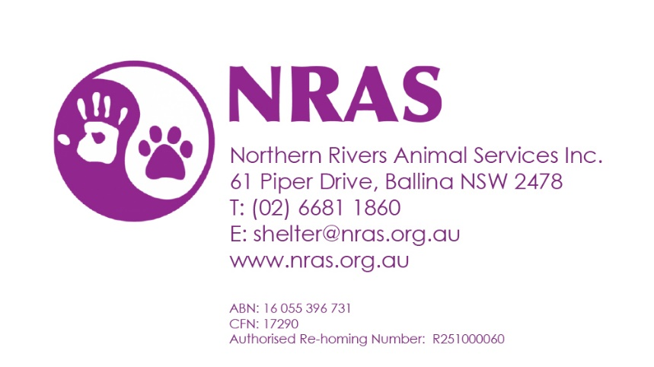
MEMBERSHIP / DONATION FORM
I wish to support Northern Rivers Animal Services (NRAS) by becoming a Member
for the financial year 20____ / 20 ____

Name:
Address:
Suburb: |  | Postcode:
Phone:
Email:

Membership: $2.00 per annum PAID Cash PAID EFT PAID Direct Deposit
Donation: Donations over $2.00 (excluding membership fee) are tax deductible
Would you like a receipt: Y / N
Would you like to receive our quarterly newsletter via email: Y / N

Signature: |  | Date:

Thank you for your support

